DIGITAL CLOCK ON LCD
Team 5 : A. Neha 192225026 , R. Varshitha 192225072
AIM:
To write an assembly language program to display digital clock on LCD with using Proteus.

SOFTWARES REQUIRED:
- Proteus software

PROGRAM:
ORG 0000H ; Start address of the program

MOV R7, #00H ; Initialize hours (HH)
MOV R6, #00H ; Initialize minutes (MM)
MOV R5, #00H ; Initialize seconds (SS)

ACALL INIT_LCD ; Initialize the LCD

MAIN_LOOP:
ACALL UPDATE_LCD ; Update the time on the LCD
ACALL DELAY_1_SEC ; Wait for 1 second
ACALL INCREMENT_TIME ; Increment time (HH:MM:SS)
SJMP MAIN_LOOP ; Repeat the process

; Subroutine to initialize the LCD
INIT_LCD:
MOV R1, #38H
ACALL CMD_WRITE
ACALL SHORT_DELAY ; Short delay between commands

MOV R1, #0CH ; Display ON, Cursor OFF
ACALL CMD_WRITE
ACALL SHORT_DELAY

MOV R1, #06H ; Auto-increment cursor
ACALL CMD_WRITE
ACALL SHORT_DELAY

MOV R1, #01H ; Clear display
ACALL CMD_WRITE
ACALL DELAY_CLEAR ; Longer delay after clearing display
RET

; Subroutine to increment time
INCREMENT_TIME:
INC R5 ; Increment seconds (SS)
CJNE R5, #60, DONE_SEC ; If seconds < 60, continue
MOV R5, #00H ; Reset seconds to 00
INC R6 ; Increment minutes (MM)
CJNE R6, #60, DONE_SEC ; If minutes < 60, continue
MOV R6, #00H ; Reset minutes to 00
INC R7 ; Increment hours (HH)
CJNE R7, #24, DONE_SEC ; If hours < 24, continue
MOV R7, #00H ; Reset hours to 00
DONE_SEC:
RET

; Subroutine to update the LCD with the current time
UPDATE_LCD:
MOV R1, #80H ; Move cursor to the first line of the LCD
ACALL CMD_WRITE
ACALL SHORT_DELAY

MOV A, R7 ; Load hours (HH) into accumulator
ACALL DISPLAY_TWO_DIGIT ; Display hours (HH)

ACALL DISPLAY_COLON ; Display ':'

MOV A, R6 ; Load minutes (MM) into accumulator
ACALL DISPLAY_TWO_DIGIT ; Display minutes (MM)

ACALL DISPLAY_COLON ; Display ':'

MOV A, R5 ; Load seconds (SS) into accumulator
ACALL DISPLAY_TWO_DIGIT ; Display seconds (SS)

RET

; Subroutine to display two-digit numbers on the LCD
DISPLAY_TWO_DIGIT:
MOV B, #10 ; Divide the value in A by 10
DIV AB ; Quotient in A (tens), remainder in B (ones)

ADD A, #30H ; Convert tens digit to ASCII
ACALL DISPLAY_CHAR ; Display the tens digit

MOV A, B ; Move the remainder (ones digit) to A
ADD A, #30H ; Convert ones digit to ASCII
ACALL DISPLAY_CHAR ; Display the ones digit

RET

; Subroutine to display colon ':' on the LCD
DISPLAY_COLON:
MOV A, #3AH ; ASCII value of ':'
ACALL DISPLAY_CHAR ; Display ':'
RET

; Subroutine to display a character on the LCD
DISPLAY_CHAR:
MOV P2, A ; Send ASCII character to data pins (P2 connected to D0-D7 of LCD)
SETB P3.2 ; Set RS to 1 (data register)
CLR P3.3 ; Set RW to 0 (write mode)
SETB P3.4 ; Set E to 1 (Enable high)
NOP ; Small delay
CLR P3.4 ; Set E to 0 (Enable low)
ACALL SHORT_DELAY ; Short delay after writing character
RET

; Subroutine to write command to the LCD
CMD_WRITE:
MOV P2, R1 ; Send command from R1 to data pins (P2 connected to D0-D7 of LCD)
CLR P3.2 ; Set RS to 0 (command register)
CLR P3.3 ; Set RW to 0 (write mode)
SETB P3.4 ; Set E to 1 (Enable high)
NOP ; Small delay
CLR P3.4 ; Set E to 0 (Enable low)
ACALL SHORT_DELAY ; Short delay after writing command
RET

; Short delay subroutine (for small delays between LCD commands)
SHORT_DELAY:
MOV R2, #50 ; Adjust for a small delay
DELAY1:
DJNZ R2, DELAY1
RET

; Longer delay subroutine for clearing the LCD
DELAY_CLEAR:
MOV R2, #200 ; Longer delay after clearing the display
DELAY2:
DJNZ R2, DELAY2
RET

; Subroutine for 1-second delay
DELAY_1_SEC:
MOV R3, #50 ; Adjust this value to create a 1-second delay
DELAY_LOOP:
DJNZ R3, DELAY_LOOP ; Simple delay loop
RET

END
CIRCUIT DIAGRAM:
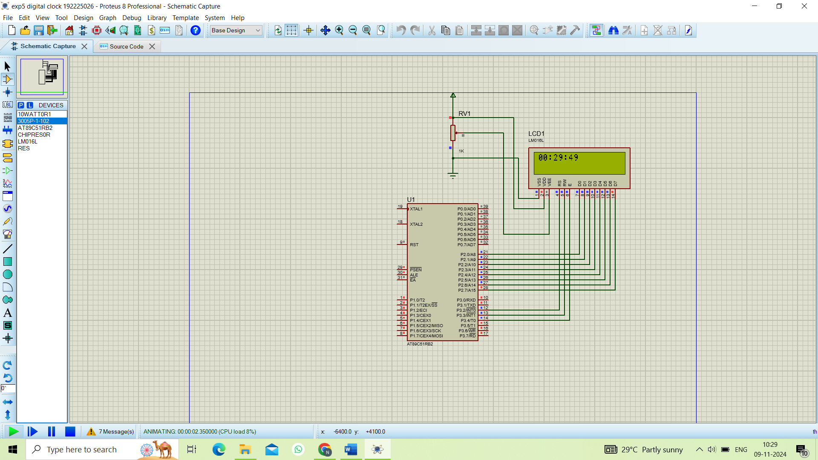

OUTPUT:
- When this program is run, the LCD will display the current time in the format HH:MM.
- Every second, the display will update to increment the seconds value.
- After reaching 59 seconds, the seconds will reset to 00, and the minutes will increment.
- Similarly, when the minutes reach 59 and increment again, they will reset to 00, and the hours will increment.
- The hours will increment from 00 to 23 in a 24-hour format. When the hours reach 23 and the next second occurs, the hours, minutes, and seconds will all reset to 00:00:00.

RESULT:
Thus, the assembly language program to display digital clock on LCD with using Proteus was executed.

